SIMATS ENGINEERING
SAVEETHA INSTITUTE OF MEDICAL AND TECHNICAL SCIENCES
CHENNAI – 602105
Department of Computer Science and Engineering

ASSESSMENT TOOL 2 – SCHEMA ANALYSIS AND VIVA VOCE

Course Code: | DSA05 | Course Title: | Query Processing for Data Science With Real Time Applications
CO Assessed: | CO2 | Assessment: | Tool 2 – Schema Analysis and Viva Voce
Weightage: |  | Total Marks: | 20 Marks
CO2 Statement: Use Python basics and SQL libraries to connect to databases SQLite, MySQL, PostgreSQL and perform CRUD operations like Create, Read, Update, Delete. (BTL6)
Student Name: | Ishwariya P | Reg. No.: | 192524445
Section / Batch: | 2025 | Date of Submission: | 4.8.26
Faculty In-charge: |  | Project Mode: | Individual Submission

Code of Conduct
I ___Ishwariya(192524445)_______________________ (Name / Reg No) certify that this submission is my original work and that I have adhered to all guidelines specified for this assessment. I understand that any violation of academic integrity rules will result in disciplinary action.
Signature: _________________________

Requirement Analysis (4 Marks) | ER Diagram Design (4 Marks) | Table Design & Normalization (4 Marks) | Database Connectivity using Python (4 Marks) | CRUD Operations (4 Marks) | Total (20 Marks)

SIMATS ENGINEERING
SAVEETHA INSTITUTE OF MEDICAL AND TECHNICAL SCIENCES

Query Processing for Data Science With Real Time Applications (DSA05)
CO2 - Assessment Tool 2: Schema Analysis and Viva Voce

Ishwariya P
192524445
B.Tech AI&DS

Scenario 1: University Student Management System

1. Aim
To design a normalized relational database for a university and implement Python-SQLite connectivity with CRUD operations.
2. Problem Statement
Student data is scattered across department spreadsheets causing duplicate IDs and inconsistent records. A centralized database is needed to manage students, faculty, courses, and enrollments, and to generate department-wise and performance reports.
3. Objective
Design entities for Department, Faculty, Student, Course and Enrollment; normalize the schema; implement SQLite connectivity with full CRUD operations in Python.
4. ER Diagram
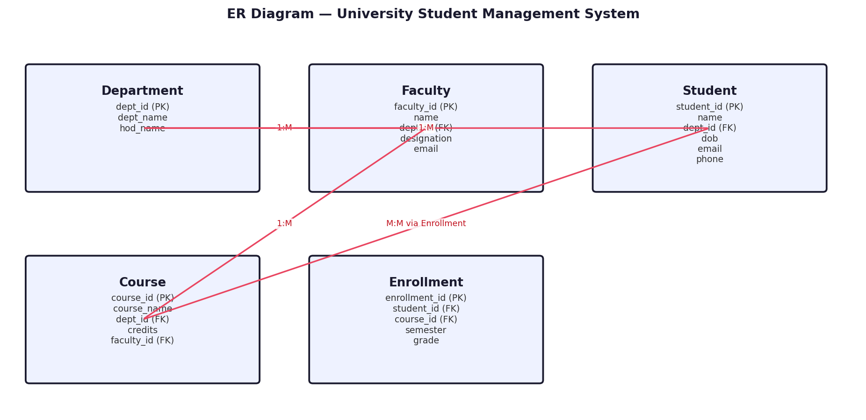
5. Table Design (Columns, Data Types, Keys)
Table | Column | Type | Constraint
Department | dept_id | INTEGER | PRIMARY KEY
 | dept_name | TEXT | -
 | hod_name | TEXT | -
Faculty | faculty_id | INTEGER | PRIMARY KEY
 | name | TEXT | -
 | dept_id | INTEGER | FK -> Department
 | designation | TEXT | -
 | email | TEXT | -
Student | student_id | INTEGER | PRIMARY KEY
 | name | TEXT | -
 | dept_id | INTEGER | FK -> Department
 | dob | TEXT | -
 | email | TEXT | -
 | phone | TEXT | -
Course | course_id | INTEGER | PRIMARY KEY
 | course_name | TEXT | -
 | dept_id | INTEGER | FK -> Department
 | credits | INTEGER | -
 | faculty_id | INTEGER | FK -> Faculty
Enrollment | enrollment_id | INTEGER | PRIMARY KEY
 | student_id | INTEGER | FK -> Student
 | course_id | INTEGER | FK -> Course
 | semester | TEXT | -
 | grade | TEXT | -
6. Normalization
1NF: All attributes hold atomic values, no repeating groups. 2NF: Every non-key attribute depends on the whole primary key; M:N links use a junction table. 3NF: No transitive dependency — e.g. dept_name and hod_name depend only on dept_id, not on student_id.
7. Database Schema Diagram
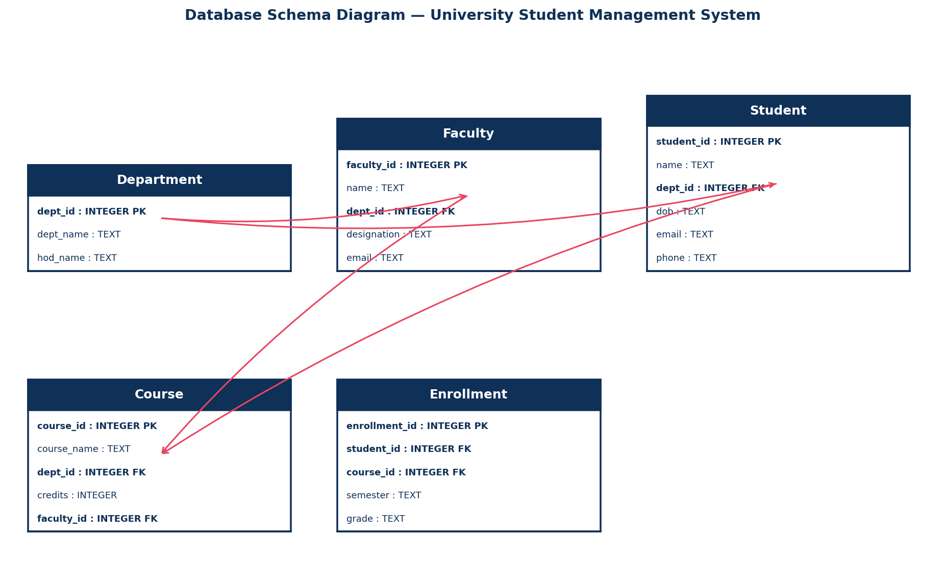
8. SQL CREATE TABLE Statements
CREATE TABLE IF NOT EXISTS Department (
dept_id INTEGER PRIMARY KEY AUTOINCREMENT,
dept_name TEXT,
hod_name TEXT
);
CREATE TABLE IF NOT EXISTS Faculty (
faculty_id INTEGER PRIMARY KEY AUTOINCREMENT,
name TEXT,
dept_id INTEGER,
designation TEXT,
email TEXT,
FOREIGN KEY (dept_id) REFERENCES Department(dept_id)
);
CREATE TABLE IF NOT EXISTS Student (
student_id INTEGER PRIMARY KEY AUTOINCREMENT,
name TEXT,
dept_id INTEGER,
dob TEXT,
email TEXT,
phone TEXT,
FOREIGN KEY (dept_id) REFERENCES Department(dept_id)
);
CREATE TABLE IF NOT EXISTS Course (
course_id INTEGER PRIMARY KEY AUTOINCREMENT,
course_name TEXT,
dept_id INTEGER,
credits INTEGER,
faculty_id INTEGER,
FOREIGN KEY (dept_id) REFERENCES Department(dept_id),
FOREIGN KEY (faculty_id) REFERENCES Faculty(faculty_id)
);
CREATE TABLE IF NOT EXISTS Enrollment (
enrollment_id INTEGER PRIMARY KEY AUTOINCREMENT,
student_id INTEGER,
course_id INTEGER,
semester TEXT,
grade TEXT,
FOREIGN KEY (student_id) REFERENCES Student(student_id),
FOREIGN KEY (course_id) REFERENCES Course(course_id)
);
9. Sample Records
Table: Student
student_id | name | dept_id | dob | email | phone
1 | Ananya Rao | 1 | 2004-05-11 | ananya@univ.edu | 9876543210
2 | Rohit Verma | 2 | 2003-11-02 | rohit@univ.edu | 9876500011
3 | Divya Sharma | 1 | 2004-01-20 | divya@univ.edu | 9876500022
4 | Karthik Iyer | 3 | 2003-07-15 | karthik@univ.edu | 9876500033
5 | Sneha Reddy | 2 | 2004-03-09 | sneha@univ.edu | 9876500044
10. Python SQLite Connectivity Program (CRUD Operations)
# University Student Management System | DB: university.db | Table: Student
# (Table already created using the CREATE TABLE statement in Section 8)
import sqlite3
conn = sqlite3.connect("university.db")
cur = conn.cursor()

def create_record(values): # CREATE
cur.execute("INSERT INTO Student (student_id, name, dept_id, dob, email, phone) VALUES (?, ?, ?, ?, ?, ?)", values)
conn.commit()

def read_records(): # READ
cur.execute("SELECT * FROM Student")
for row in cur.fetchall(): print(row)

def update_record(record_id, new_value): # UPDATE
cur.execute("UPDATE Student SET name = ? WHERE student_id = ?", (new_value, record_id))
conn.commit()

def delete_record(record_id): # DELETE
cur.execute("DELETE FROM Student WHERE student_id = ?", (record_id,))
conn.commit()

if __name__ == "__main__":
create_record([1,"Ananya Rao",1,"2004-05-11","ananya@univ.edu","9876543210"])
print("-- All Records --"); read_records()
update_record(1, "Updated Name")
print("-- After Update --"); read_records()
delete_record(1)
print("-- After Delete --"); read_records()
conn.close()

11. Expected Output
-- All Records --
(1, 'Ananya Rao', 1, '2004-05-11', 'ananya@univ.edu', '9876543210')
(2, 'Rohit Verma', 2, '2003-11-02', 'rohit@univ.edu', '9876500011')
(3, 'Divya Sharma', 1, '2004-01-20', 'divya@univ.edu', '9876500022')
(4, 'Karthik Iyer', 3, '2003-07-15', 'karthik@univ.edu', '9876500033')
(5, 'Sneha Reddy', 2, '2004-03-09', 'sneha@univ.edu', '9876500044')
-- After Update: record student_id=1 shows the new value.
-- After Delete: record student_id=1 no longer appears.
12. Result
The relational database for "University Student Management System" was designed, normalized up to 3NF, and successfully connected using Python's sqlite3 module. All CRUD operations (Create, Read, Update, Delete) were executed and verified successfully.

Scenario 2: Hospital Patient Record Management System
1. Aim
To design a relational database for hospital operations and implement Python-SQLite connectivity with CRUD operations.
2. Problem Statement
Patient records are maintained manually, making it difficult to track history, consultations, prescriptions and billing. A database-driven system is required to store patient, doctor, appointment, prescription, lab test and billing data.
3. Objective
Design entities for Doctor, Patient, Appointment, Prescription and Billing; normalize the schema; implement SQLite connectivity with CRUD operations.
4. ER Diagram
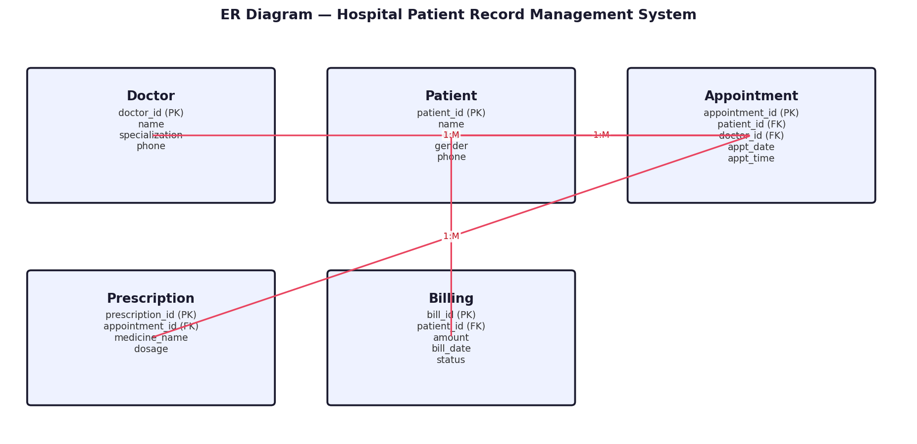
5. Table Design (Columns, Data Types, Keys)
Table | Column | Type | Constraint
Doctor | doctor_id | INTEGER | PRIMARY KEY
 | name | TEXT | -
 | specialization | TEXT | -
 | phone | TEXT | -
Patient | patient_id | INTEGER | PRIMARY KEY
 | name | TEXT | -
 | dob | TEXT | -
 | gender | TEXT | -
 | phone | TEXT | -
Appointment | appointment_id | INTEGER | PRIMARY KEY
 | patient_id | INTEGER | FK -> Patient
 | doctor_id | INTEGER | FK -> Doctor
 | appt_date | TEXT | -
 | appt_time | TEXT | -
Prescription | prescription_id | INTEGER | PRIMARY KEY
 | appointment_id | INTEGER | FK -> Appointment
 | medicine_name | TEXT | -
 | dosage | TEXT | -
Billing | bill_id | INTEGER | PRIMARY KEY
 | patient_id | INTEGER | FK -> Patient
 | amount | REAL | -
 | bill_date | TEXT | -
 | status | TEXT | -
6. Normalization
1NF: All attributes hold atomic values, no repeating groups. 2NF: Every non-key attribute depends on the whole primary key; M:N links use a junction table. 3NF: No transitive dependency — e.g. specialization depends only on doctor_id, not on appointment_id.
7. Database Schema Diagram
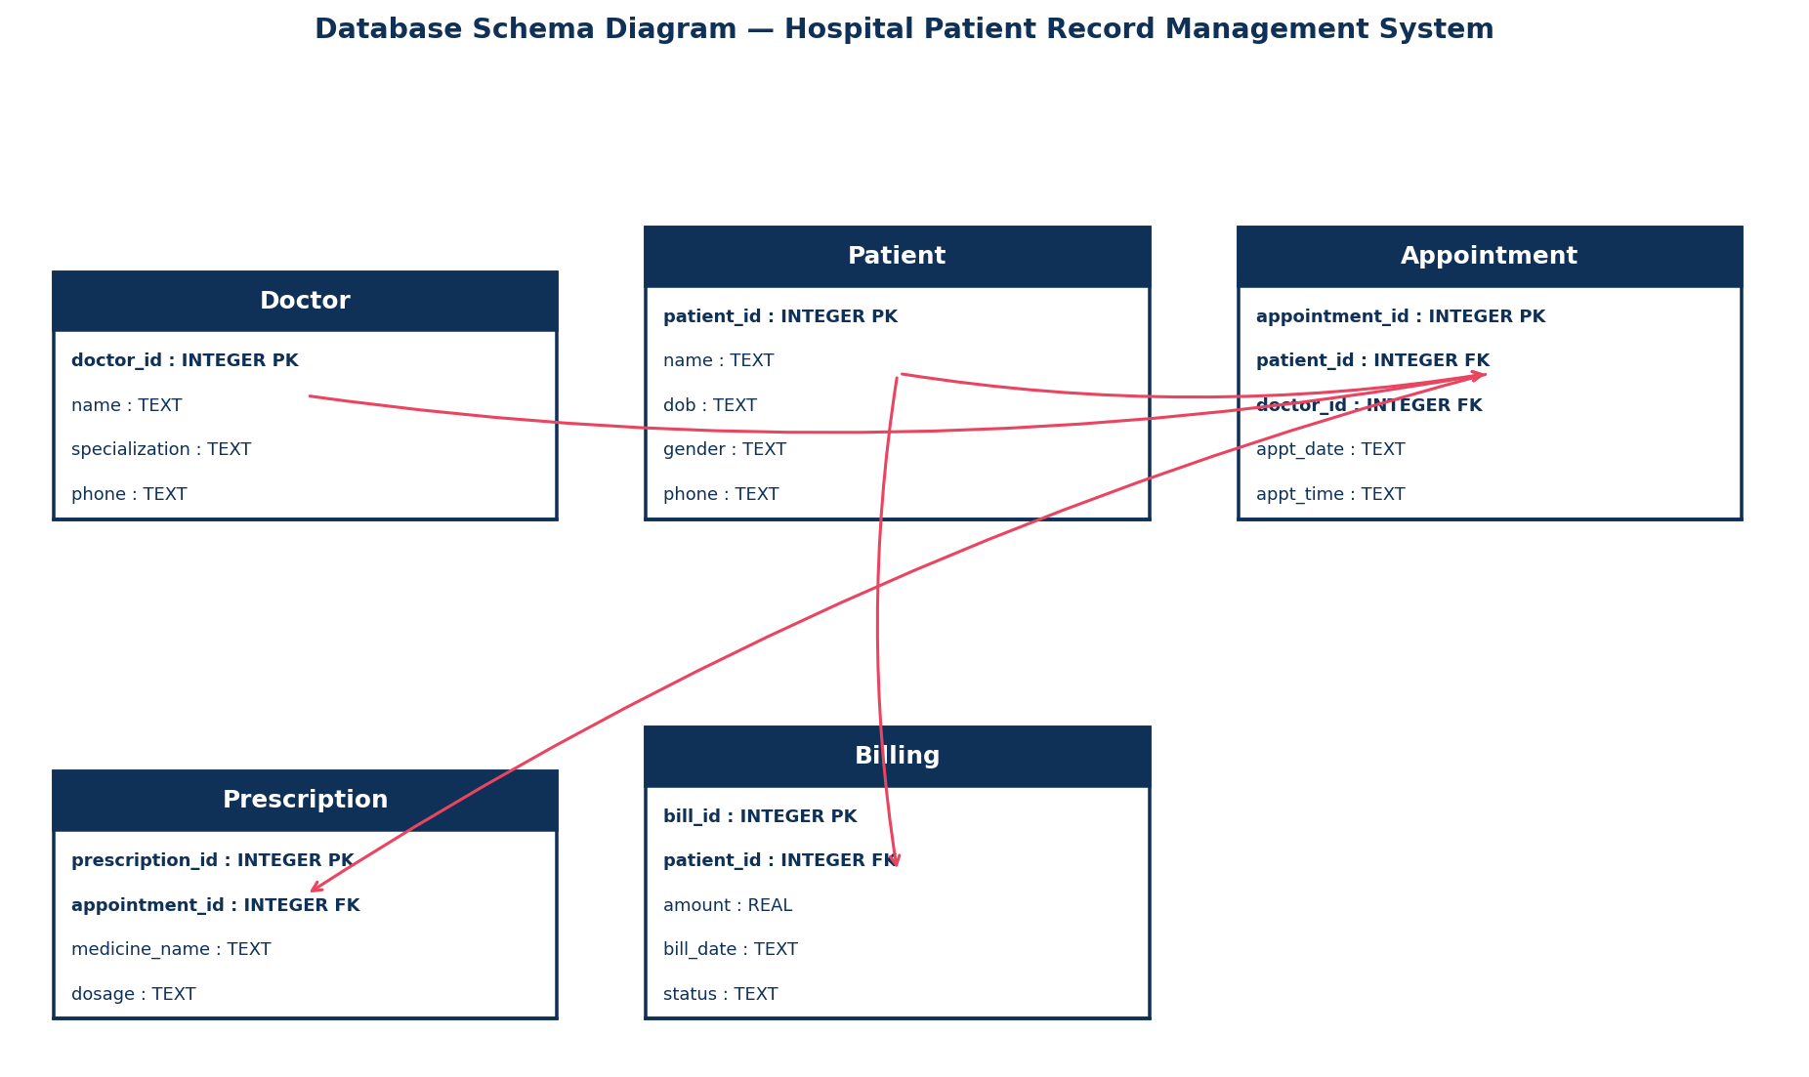
8. SQL CREATE TABLE Statements
CREATE TABLE IF NOT EXISTS Doctor (
doctor_id INTEGER PRIMARY KEY AUTOINCREMENT,
name TEXT,
specialization TEXT,
phone TEXT
);
CREATE TABLE IF NOT EXISTS Patient (
patient_id INTEGER PRIMARY KEY AUTOINCREMENT,
name TEXT,
dob TEXT,
gender TEXT,
phone TEXT
);
CREATE TABLE IF NOT EXISTS Appointment (
appointment_id INTEGER PRIMARY KEY AUTOINCREMENT,
patient_id INTEGER,
doctor_id INTEGER,
appt_date TEXT,
appt_time TEXT,
FOREIGN KEY (patient_id) REFERENCES Patient(patient_id),
FOREIGN KEY (doctor_id) REFERENCES Doctor(doctor_id)
);
CREATE TABLE IF NOT EXISTS Prescription (
prescription_id INTEGER PRIMARY KEY AUTOINCREMENT,
appointment_id INTEGER,
medicine_name TEXT,
dosage TEXT,
FOREIGN KEY (appointment_id) REFERENCES Appointment(appointment_id)
);
CREATE TABLE IF NOT EXISTS Billing (
bill_id INTEGER PRIMARY KEY AUTOINCREMENT,
patient_id INTEGER,
amount REAL,
bill_date TEXT,
status TEXT,
FOREIGN KEY (patient_id) REFERENCES Patient(patient_id)
);
9. Sample Records
Table: Patient
patient_id | name | dob | gender | phone
1 | Meera Nair | 1990-04-12 | F | 9998887771
2 | Arjun Menon | 1985-09-23 | M | 9998887772
3 | Priya Das | 1995-12-01 | F | 9998887773
4 | Suresh Pillai | 1978-06-18 | M | 9998887774
5 | Lakshmi Iyer | 2000-02-28 | F | 9998887775
10. Python SQLite Connectivity Program (CRUD Operations)
# Hospital Patient Record Management System | DB: hospital.db | Table: Patient
# (Table already created using the CREATE TABLE statement in Section 8)
import sqlite3
conn = sqlite3.connect("hospital.db")
cur = conn.cursor()

def create_record(values): # CREATE
cur.execute("INSERT INTO Patient (patient_id, name, dob, gender, phone) VALUES (?, ?, ?, ?, ?)", values)
conn.commit()

def read_records(): # READ
cur.execute("SELECT * FROM Patient")
for row in cur.fetchall(): print(row)

def update_record(record_id, new_value): # UPDATE
cur.execute("UPDATE Patient SET name = ? WHERE patient_id = ?", (new_value, record_id))
conn.commit()

def delete_record(record_id): # DELETE
cur.execute("DELETE FROM Patient WHERE patient_id = ?", (record_id,))
conn.commit()

if __name__ == "__main__":
create_record([1,"Meera Nair","1990-04-12","F","9998887771"])
print("-- All Records --"); read_records()
update_record(1, "Updated Name")
print("-- After Update --"); read_records()
delete_record(1)
print("-- After Delete --"); read_records()
conn.close()

11. Expected Output
-- All Records --
(1, 'Meera Nair', '1990-04-12', 'F', '9998887771')
(2, 'Arjun Menon', '1985-09-23', 'M', '9998887772')
(3, 'Priya Das', '1995-12-01', 'F', '9998887773')
(4, 'Suresh Pillai', '1978-06-18', 'M', '9998887774')
(5, 'Lakshmi Iyer', '2000-02-28', 'F', '9998887775')
-- After Update: record patient_id=1 shows the new value.
-- After Delete: record patient_id=1 no longer appears.
12. Result
The relational database for "Hospital Patient Record Management System" was designed, normalized up to 3NF, and successfully connected using Python's sqlite3 module. All CRUD operations (Create, Read, Update, Delete) were executed and verified successfully.

Scenario 3: E-Commerce Online Shopping Platform
1. Aim
To design a relational database for an e-commerce platform and implement Python-SQLite connectivity with CRUD operations.
2. Problem Statement
The company needs to track customers, products, orders, payments and reviews accurately to generate sales and revenue reports while keeping inventory consistent after every purchase.
3. Objective
Design entities for Customer, Product, Orders, OrderItem and Payment; normalize the schema; implement SQLite connectivity with CRUD operations.
4. ER Diagram
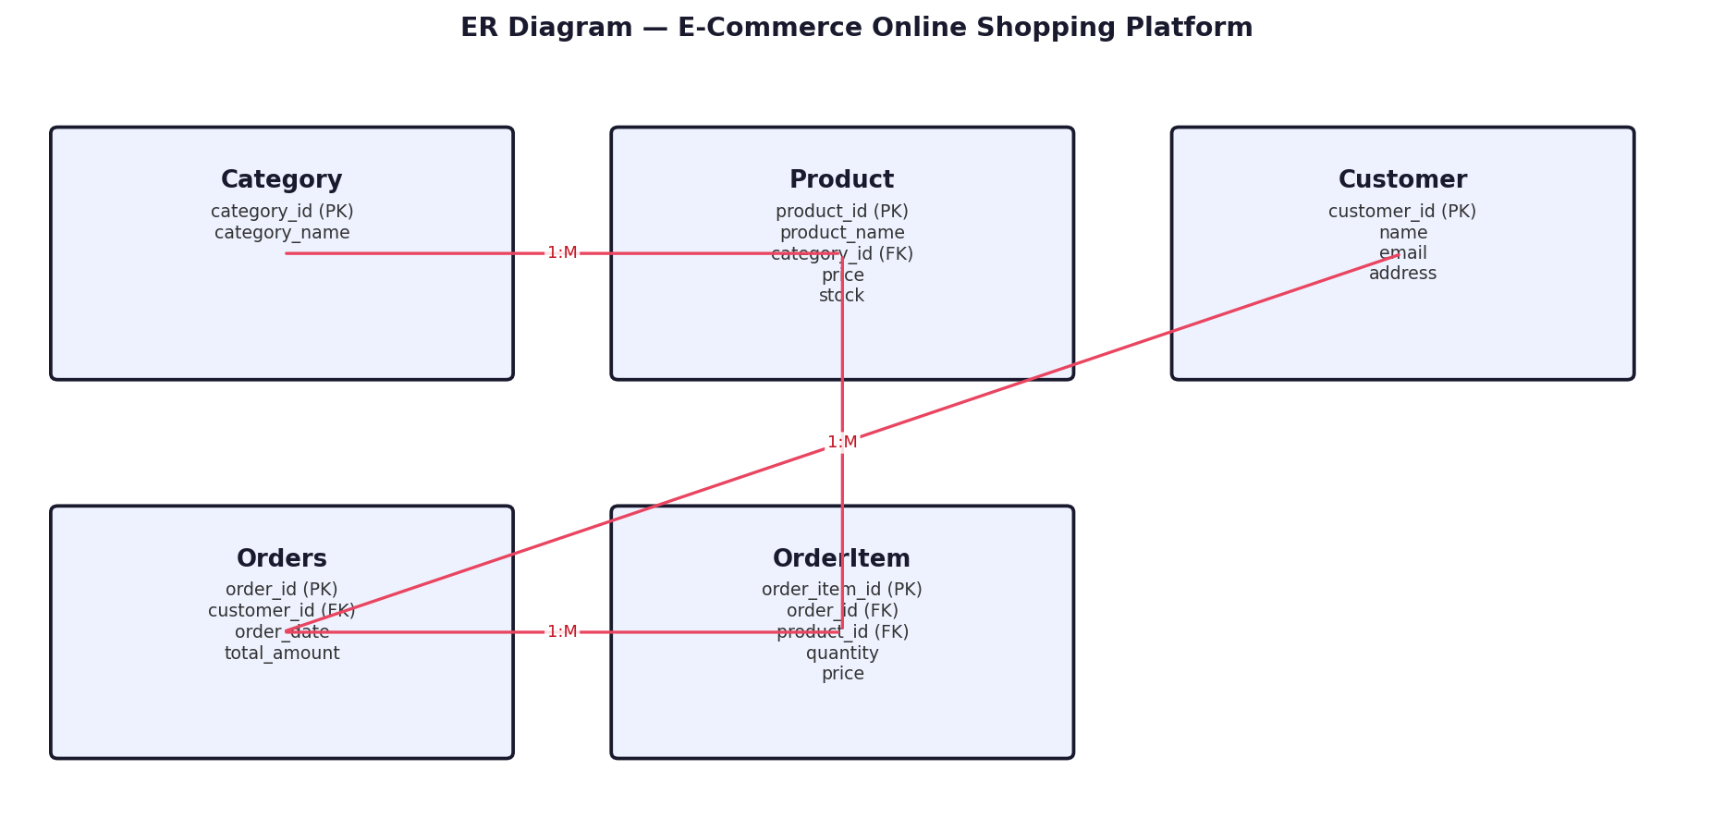
5. Table Design (Columns, Data Types, Keys)
Table | Column | Type | Constraint
Category | category_id | INTEGER | PRIMARY KEY
 | category_name | TEXT | -
Product | product_id | INTEGER | PRIMARY KEY
 | product_name | TEXT | -
 | category_id | INTEGER | FK -> Category
 | price | REAL | -
 | stock | INTEGER | -
Customer | customer_id | INTEGER | PRIMARY KEY
 | name | TEXT | -
 | email | TEXT | -
 | address | TEXT | -
Orders | order_id | INTEGER | PRIMARY KEY
 | customer_id | INTEGER | FK -> Customer
 | order_date | TEXT | -
 | total_amount | REAL | -
OrderItem | order_item_id | INTEGER | PRIMARY KEY
 | order_id | INTEGER | FK -> Orders
 | product_id | INTEGER | FK -> Product
 | quantity | INTEGER | -
 | price | REAL | -
6. Normalization
1NF: All attributes hold atomic values, no repeating groups. 2NF: Every non-key attribute depends on the whole primary key; M:N links use a junction table. 3NF: No transitive dependency — e.g. category_name depends only on category_id, not on product_id.
7. Database Schema Diagram
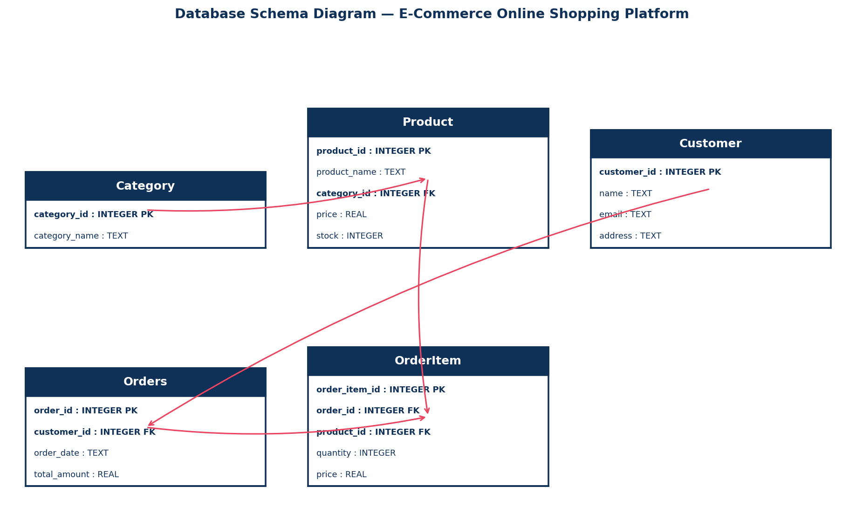
8. SQL CREATE TABLE Statements
CREATE TABLE IF NOT EXISTS Category (
category_id INTEGER PRIMARY KEY AUTOINCREMENT,
category_name TEXT
);
CREATE TABLE IF NOT EXISTS Product (
product_id INTEGER PRIMARY KEY AUTOINCREMENT,
product_name TEXT,
category_id INTEGER,
price REAL,
stock INTEGER,
FOREIGN KEY (category_id) REFERENCES Category(category_id)
);
CREATE TABLE IF NOT EXISTS Customer (
customer_id INTEGER PRIMARY KEY AUTOINCREMENT,
name TEXT,
email TEXT,
address TEXT
);
CREATE TABLE IF NOT EXISTS Orders (
order_id INTEGER PRIMARY KEY AUTOINCREMENT,
customer_id INTEGER,
order_date TEXT,
total_amount REAL,
FOREIGN KEY (customer_id) REFERENCES Customer(customer_id)
);
CREATE TABLE IF NOT EXISTS OrderItem (
order_item_id INTEGER PRIMARY KEY AUTOINCREMENT,
order_id INTEGER,
product_id INTEGER,
quantity INTEGER,
price REAL,
FOREIGN KEY (order_id) REFERENCES Orders(order_id),
FOREIGN KEY (product_id) REFERENCES Product(product_id)
);
9. Sample Records
Table: Product
product_id | product_name | category_id | price | stock
1 | Wireless Mouse | 1 | 699 | 120
2 | Cotton T-Shirt | 2 | 499 | 300
3 | Novel - Data Age | 3 | 349 | 80
4 | LED Desk Lamp | 4 | 899 | 60
5 | Bluetooth Speaker | 1 | 1499 | 45
10. Python SQLite Connectivity Program (CRUD Operations)
# E-Commerce Online Shopping Platform | DB: ecommerce.db | Table: Product
# (Table already created using the CREATE TABLE statement in Section 8)
import sqlite3
conn = sqlite3.connect("ecommerce.db")
cur = conn.cursor()

def create_record(values): # CREATE
cur.execute("INSERT INTO Product (product_id, product_name, category_id, price, stock) VALUES (?, ?, ?, ?, ?)", values)
conn.commit()

def read_records(): # READ
cur.execute("SELECT * FROM Product")
for row in cur.fetchall(): print(row)

def update_record(record_id, new_value): # UPDATE
cur.execute("UPDATE Product SET product_name = ? WHERE product_id = ?", (new_value, record_id))
conn.commit()

def delete_record(record_id): # DELETE
cur.execute("DELETE FROM Product WHERE product_id = ?", (record_id,))
conn.commit()

if __name__ == "__main__":
create_record([1,"Wireless Mouse",1,699,120])
print("-- All Records --"); read_records()
update_record(1, "Updated Name")
print("-- After Update --"); read_records()
delete_record(1)
print("-- After Delete --"); read_records()
conn.close()

11. Expected Output
-- All Records --
(1, 'Wireless Mouse', 1, 699, 120)
(2, 'Cotton T-Shirt', 2, 499, 300)
(3, 'Novel - Data Age', 3, 349, 80)
(4, 'LED Desk Lamp', 4, 899, 60)
(5, 'Bluetooth Speaker', 1, 1499, 45)
-- After Update: record product_id=1 shows the new value.
-- After Delete: record product_id=1 no longer appears.
12. Result
The relational database for "E-Commerce Online Shopping Platform" was designed, normalized up to 3NF, and successfully connected using Python's sqlite3 module. All CRUD operations (Create, Read, Update, Delete) were executed and verified successfully.

Scenario 4: Library Management System
1. Aim
To design a relational database for library operations and implement Python-SQLite connectivity with CRUD operations.
2. Problem Statement
Manual tracking of books and members leads to misplaced records and inaccurate issue/return data. An automated system is needed to manage books, members, transactions and overdue fines.
3. Objective
Design entities for Publisher, Book, Member and Transaction; normalize the schema; implement SQLite connectivity with CRUD operations.
4. ER Diagram
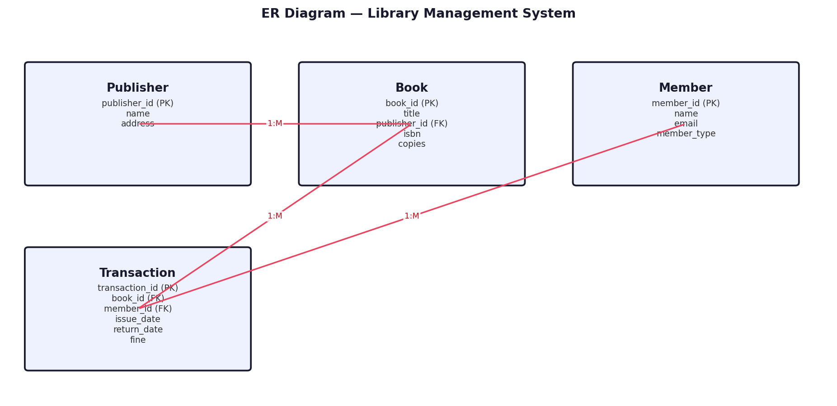
5. Table Design (Columns, Data Types, Keys)
Table | Column | Type | Constraint
Publisher | publisher_id | INTEGER | PRIMARY KEY
 | name | TEXT | -
 | address | TEXT | -
Book | book_id | INTEGER | PRIMARY KEY
 | title | TEXT | -
 | publisher_id | INTEGER | FK -> Publisher
 | isbn | TEXT | -
 | copies | INTEGER | -
Member | member_id | INTEGER | PRIMARY KEY
 | name | TEXT | -
 | email | TEXT | -
 | member_type | TEXT | -
Transaction | transaction_id | INTEGER | PRIMARY KEY
 | book_id | INTEGER | FK -> Book
 | member_id | INTEGER | FK -> Member
 | issue_date | TEXT | -
 | return_date | TEXT | -
 | fine | REAL | -
6. Normalization
1NF: All attributes hold atomic values, no repeating groups. 2NF: Every non-key attribute depends on the whole primary key; M:N links use a junction table. 3NF: No transitive dependency — e.g. publisher name depends only on publisher_id, not on book_id.
7. Database Schema Diagram
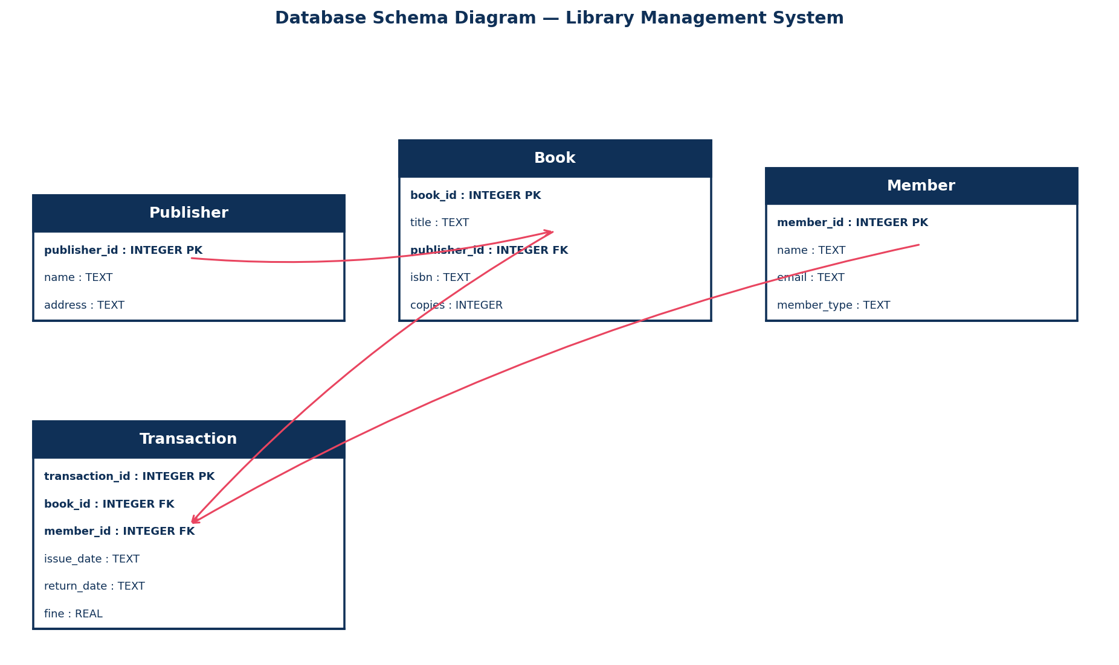
8. SQL CREATE TABLE Statements
CREATE TABLE IF NOT EXISTS Publisher (
publisher_id INTEGER PRIMARY KEY AUTOINCREMENT,
name TEXT,
address TEXT
);
CREATE TABLE IF NOT EXISTS Book (
book_id INTEGER PRIMARY KEY AUTOINCREMENT,
title TEXT,
publisher_id INTEGER,
isbn TEXT,
copies INTEGER,
FOREIGN KEY (publisher_id) REFERENCES Publisher(publisher_id)
);
CREATE TABLE IF NOT EXISTS Member (
member_id INTEGER PRIMARY KEY AUTOINCREMENT,
name TEXT,
email TEXT,
member_type TEXT
);
CREATE TABLE IF NOT EXISTS Transaction (
transaction_id INTEGER PRIMARY KEY AUTOINCREMENT,
book_id INTEGER,
member_id INTEGER,
issue_date TEXT,
return_date TEXT,
fine REAL,
FOREIGN KEY (book_id) REFERENCES Book(book_id),
FOREIGN KEY (member_id) REFERENCES Member(member_id)
);
9. Sample Records
Table: Book
book_id | title | publisher_id | isbn | copies
1 | Database Systems | 1 | 9780131877446 | 4
2 | Python Programming | 2 | 9780134444321 | 6
3 | Clean Code | 3 | 9780132350884 | 3
4 | Operating Systems | 1 | 9780131429383 | 5
5 | Computer Networks | 2 | 9780132126953 | 2
10. Python SQLite Connectivity Program (CRUD Operations)
# Library Management System | DB: library.db | Table: Book
# (Table already created using the CREATE TABLE statement in Section 8)
import sqlite3
conn = sqlite3.connect("library.db")
cur = conn.cursor()

def create_record(values): # CREATE
cur.execute("INSERT INTO Book (book_id, title, publisher_id, isbn, copies) VALUES (?, ?, ?, ?, ?)", values)
conn.commit()

def read_records(): # READ
cur.execute("SELECT * FROM Book")
for row in cur.fetchall(): print(row)

def update_record(record_id, new_value): # UPDATE
cur.execute("UPDATE Book SET title = ? WHERE book_id = ?", (new_value, record_id))
conn.commit()

def delete_record(record_id): # DELETE
cur.execute("DELETE FROM Book WHERE book_id = ?", (record_id,))
conn.commit()

if __name__ == "__main__":
create_record([1,"Database Systems",1,"9780131877446",4])
print("-- All Records --"); read_records()
update_record(1, "Updated Name")
print("-- After Update --"); read_records()
delete_record(1)
print("-- After Delete --"); read_records()
conn.close()

11. Expected Output
-- All Records --
(1, 'Database Systems', 1, '9780131877446', 4)
(2, 'Python Programming', 2, '9780134444321', 6)
(3, 'Clean Code', 3, '9780132350884', 3)
(4, 'Operating Systems', 1, '9780131429383', 5)
(5, 'Computer Networks', 2, '9780132126953', 2)
-- After Update: record book_id=1 shows the new value.
-- After Delete: record book_id=1 no longer appears.
12. Result
The relational database for "Library Management System" was designed, normalized up to 3NF, and successfully connected using Python's sqlite3 module. All CRUD operations (Create, Read, Update, Delete) were executed and verified successfully.

Scenario 5: Hotel Reservation and Booking System
1. Aim
To design a relational database for hotel reservations and implement Python-SQLite connectivity with CRUD operations.
2. Problem Statement
The hotel chain needs a centralized system to manage room availability, reservations, payments and customer history across multiple branches while minimizing data redundancy.
3. Objective
Design entities for Branch, Room, Customer and Reservation; normalize the schema; implement SQLite connectivity with CRUD operations.
4. ER Diagram
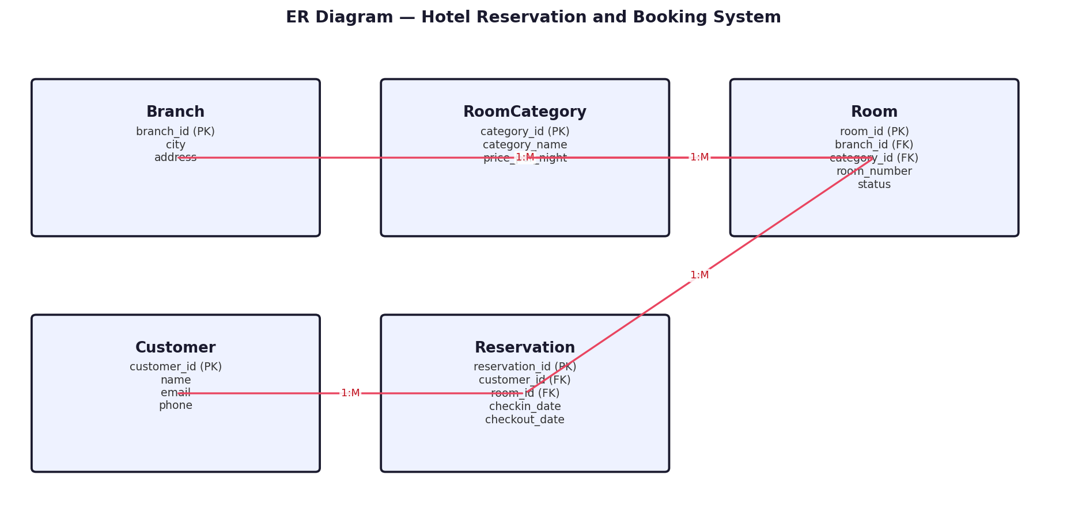
5. Table Design (Columns, Data Types, Keys)
Table | Column | Type | Constraint
Branch | branch_id | INTEGER | PRIMARY KEY
 | city | TEXT | -
 | address | TEXT | -
RoomCategory | category_id | INTEGER | PRIMARY KEY
 | category_name | TEXT | -
 | price_per_night | REAL | -
Room | room_id | INTEGER | PRIMARY KEY
 | branch_id | INTEGER | FK -> Branch
 | category_id | INTEGER | FK -> RoomCategory
 | room_number | TEXT | -
 | status | TEXT | -
Customer | customer_id | INTEGER | PRIMARY KEY
 | name | TEXT | -
 | email | TEXT | -
 | phone | TEXT | -
Reservation | reservation_id | INTEGER | PRIMARY KEY
 | customer_id | INTEGER | FK -> Customer
 | room_id | INTEGER | FK -> Room
 | checkin_date | TEXT | -
 | checkout_date | TEXT | -
6. Normalization
1NF: All attributes hold atomic values, no repeating groups. 2NF: Every non-key attribute depends on the whole primary key; M:N links use a junction table. 3NF: No transitive dependency — e.g. price_per_night depends only on category_id, not on room_id.
7. Database Schema Diagram
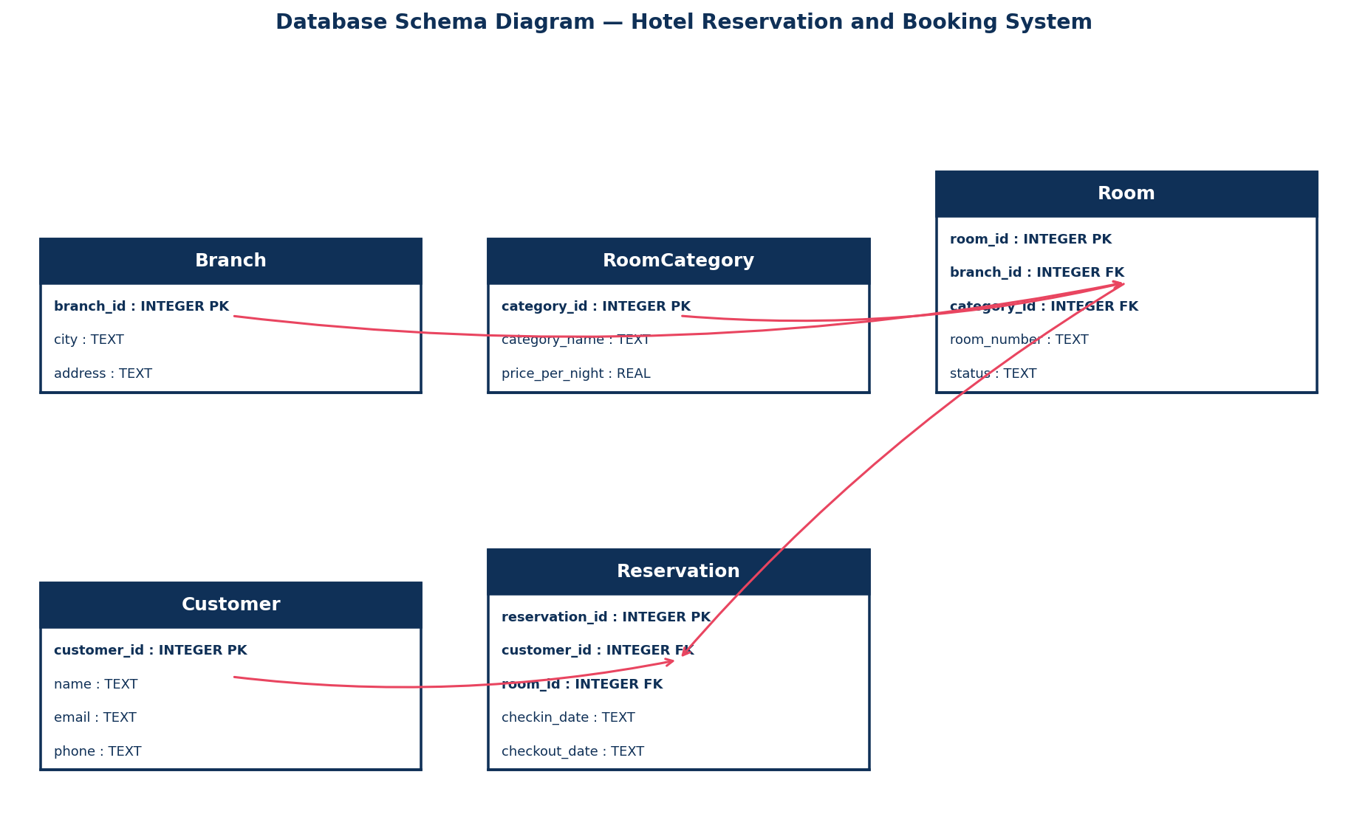
8. SQL CREATE TABLE Statements
CREATE TABLE IF NOT EXISTS Branch (
branch_id INTEGER PRIMARY KEY AUTOINCREMENT,
city TEXT,
address TEXT
);
CREATE TABLE IF NOT EXISTS RoomCategory (
category_id INTEGER PRIMARY KEY AUTOINCREMENT,
category_name TEXT,
price_per_night REAL
);
CREATE TABLE IF NOT EXISTS Room (
room_id INTEGER PRIMARY KEY AUTOINCREMENT,
branch_id INTEGER,
category_id INTEGER,
room_number TEXT,
status TEXT,
FOREIGN KEY (branch_id) REFERENCES Branch(branch_id),
FOREIGN KEY (category_id) REFERENCES RoomCategory(category_id)
);
CREATE TABLE IF NOT EXISTS Customer (
customer_id INTEGER PRIMARY KEY AUTOINCREMENT,
name TEXT,
email TEXT,
phone TEXT
);
CREATE TABLE IF NOT EXISTS Reservation (
reservation_id INTEGER PRIMARY KEY AUTOINCREMENT,
customer_id INTEGER,
room_id INTEGER,
checkin_date TEXT,
checkout_date TEXT,
FOREIGN KEY (customer_id) REFERENCES Customer(customer_id),
FOREIGN KEY (room_id) REFERENCES Room(room_id)
);
9. Sample Records
Table: Reservation
reservation_id | customer_id | room_id | checkin_date | checkout_date
1 | 1 | 101 | 2026-07-01 | 2026-07-03
2 | 2 | 102 | 2026-07-02 | 2026-07-05
3 | 1 | 103 | 2026-07-04 | 2026-07-06
4 | 3 | 201 | 2026-07-05 | 2026-07-07
5 | 2 | 202 | 2026-07-06 | 2026-07-08
10. Python SQLite Connectivity Program (CRUD Operations)
# Hotel Reservation and Booking System | DB: hotel.db | Table: Reservation
# (Table already created using the CREATE TABLE statement in Section 8)
import sqlite3
conn = sqlite3.connect("hotel.db")
cur = conn.cursor()

def create_record(values): # CREATE
cur.execute("INSERT INTO Reservation (reservation_id, customer_id, room_id, checkin_date, checkout_date) VALUES (?, ?, ?, ?, ?)", values)
conn.commit()

def read_records(): # READ
cur.execute("SELECT * FROM Reservation")
for row in cur.fetchall(): print(row)

def update_record(record_id, new_value): # UPDATE
cur.execute("UPDATE Reservation SET customer_id = ? WHERE reservation_id = ?", (new_value, record_id))
conn.commit()

def delete_record(record_id): # DELETE
cur.execute("DELETE FROM Reservation WHERE reservation_id = ?", (record_id,))
conn.commit()

if __name__ == "__main__":
create_record([1,1,101,"2026-07-01","2026-07-03"])
print("-- All Records --"); read_records()
update_record(1, 0)
print("-- After Update --"); read_records()
delete_record(1)
print("-- After Delete --"); read_records()
conn.close()

11. Expected Output
-- All Records --
(1, 1, 101, '2026-07-01', '2026-07-03')
(2, 2, 102, '2026-07-02', '2026-07-05')
(3, 1, 103, '2026-07-04', '2026-07-06')
(4, 3, 201, '2026-07-05', '2026-07-07')
(5, 2, 202, '2026-07-06', '2026-07-08')
-- After Update: record reservation_id=1 shows the new value.
-- After Delete: record reservation_id=1 no longer appears.
12. Result
The relational database for "Hotel Reservation and Booking System" was designed, normalized up to 3NF, and successfully connected using Python's sqlite3 module. All CRUD operations (Create, Read, Update, Delete) were executed and verified successfully.

Scenario 6: Banking and Customer Account Management System
1. Aim
To design a relational database for banking operations and implement Python-SQLite connectivity with CRUD operations.
2. Problem Statement
The bank needs a secure system to manage customers, accounts, transactions and loans across branches, with quick retrieval of balances and transaction history.
3. Objective
Design entities for Branch, Customer, Account and Transaction; normalize the schema; implement SQLite connectivity with CRUD operations.
4. ER Diagram
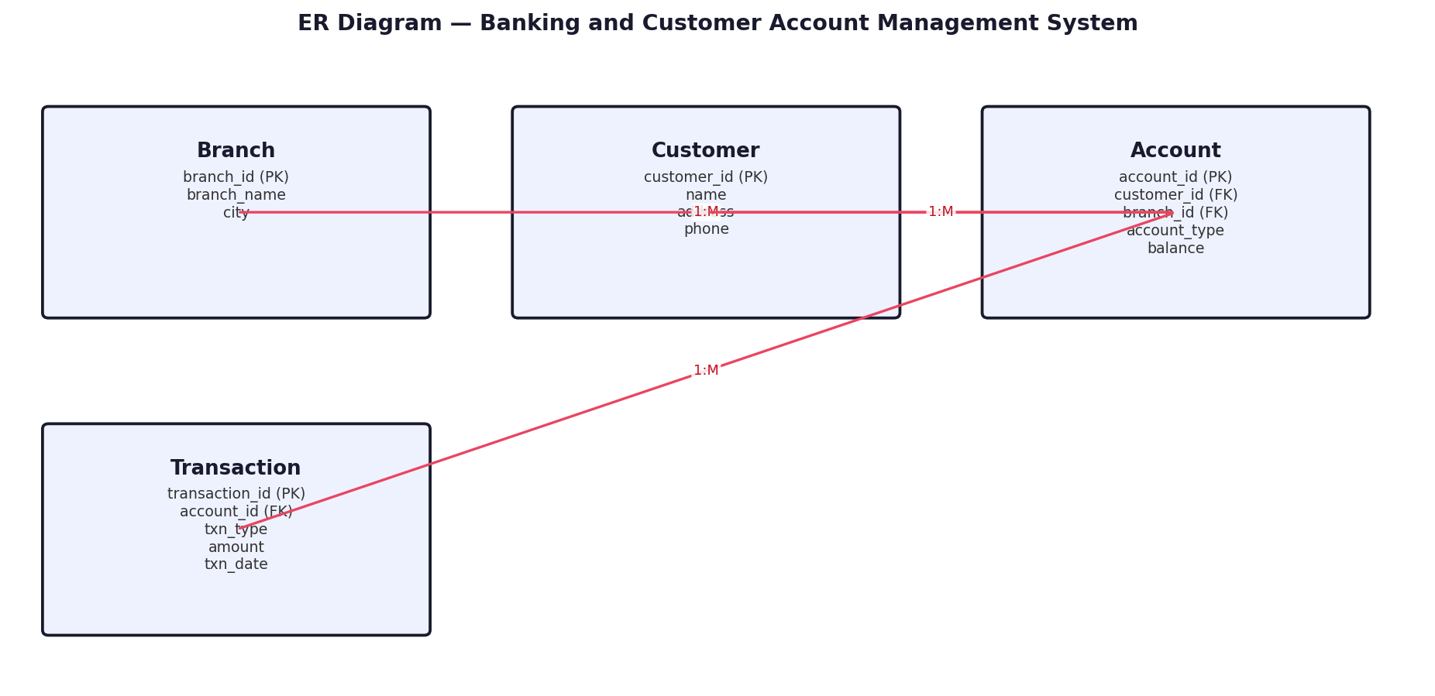
5. Table Design (Columns, Data Types, Keys)
Table | Column | Type | Constraint
Branch | branch_id | INTEGER | PRIMARY KEY
 | branch_name | TEXT | -
 | city | TEXT | -
Customer | customer_id | INTEGER | PRIMARY KEY
 | name | TEXT | -
 | address | TEXT | -
 | phone | TEXT | -
Account | account_id | INTEGER | PRIMARY KEY
 | customer_id | INTEGER | FK -> Customer
 | branch_id | INTEGER | FK -> Branch
 | account_type | TEXT | -
 | balance | REAL | -
Transaction | transaction_id | INTEGER | PRIMARY KEY
 | account_id | INTEGER | FK -> Account
 | txn_type | TEXT | -
 | amount | REAL | -
 | txn_date | TEXT | -
6. Normalization
1NF: All attributes hold atomic values, no repeating groups. 2NF: Every non-key attribute depends on the whole primary key; M:N links use a junction table. 3NF: No transitive dependency — e.g. branch_name depends only on branch_id, not on account_id.
7. Database Schema Diagram
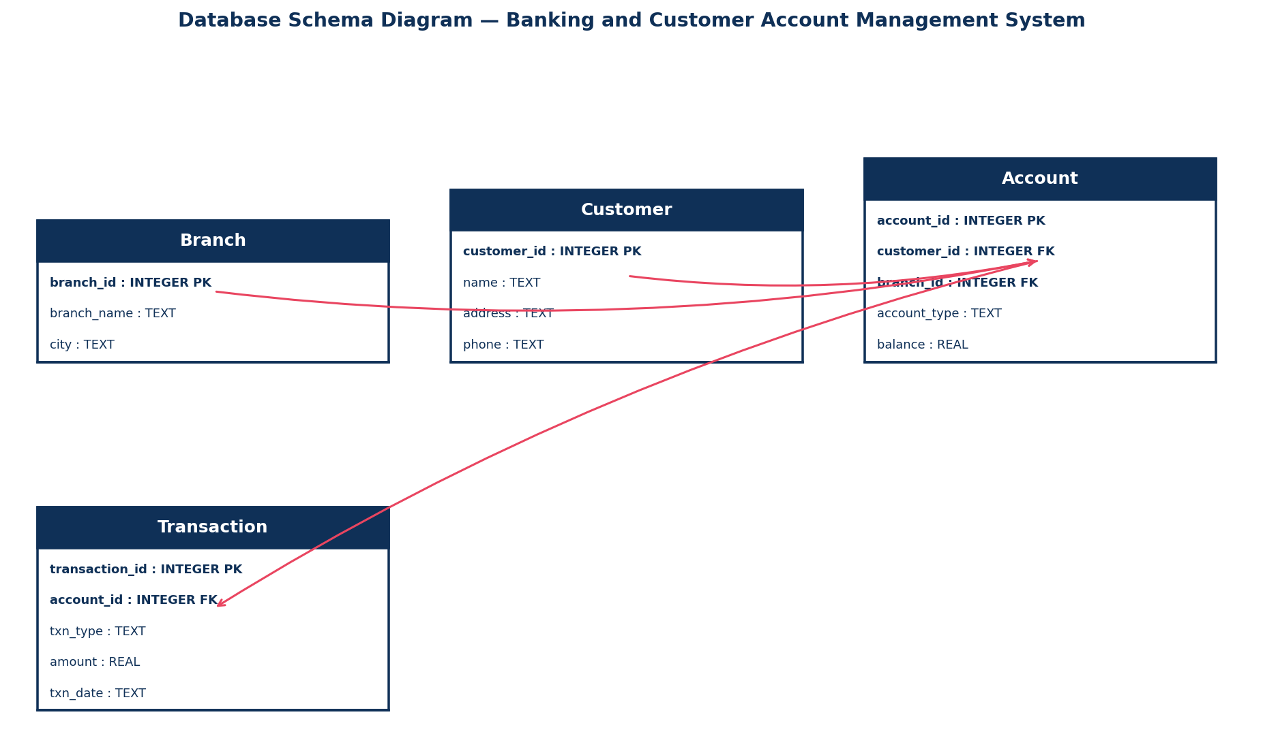
8. SQL CREATE TABLE Statements
CREATE TABLE IF NOT EXISTS Branch (
branch_id INTEGER PRIMARY KEY AUTOINCREMENT,
branch_name TEXT,
city TEXT
);
CREATE TABLE IF NOT EXISTS Customer (
customer_id INTEGER PRIMARY KEY AUTOINCREMENT,
name TEXT,
address TEXT,
phone TEXT
);
CREATE TABLE IF NOT EXISTS Account (
account_id INTEGER PRIMARY KEY AUTOINCREMENT,
customer_id INTEGER,
branch_id INTEGER,
account_type TEXT,
balance REAL,
FOREIGN KEY (customer_id) REFERENCES Customer(customer_id),
FOREIGN KEY (branch_id) REFERENCES Branch(branch_id)
);
CREATE TABLE IF NOT EXISTS Transaction (
transaction_id INTEGER PRIMARY KEY AUTOINCREMENT,
account_id INTEGER,
txn_type TEXT,
amount REAL,
txn_date TEXT,
FOREIGN KEY (account_id) REFERENCES Account(account_id)
);
9. Sample Records
Table: Account
account_id | customer_id | branch_id | account_type | balance
1 | 1 | 1 | Savings | 25000
2 | 2 | 1 | Current | 120000
3 | 3 | 2 | Savings | 8500
4 | 4 | 2 | Savings | 42000
5 | 5 | 3 | Current | 67000
10. Python SQLite Connectivity Program (CRUD Operations)
# Banking and Customer Account Management System | DB: banking.db | Table: Account
# (Table already created using the CREATE TABLE statement in Section 8)
import sqlite3
conn = sqlite3.connect("banking.db")
cur = conn.cursor()

def create_record(values): # CREATE
cur.execute("INSERT INTO Account (account_id, customer_id, branch_id, account_type, balance) VALUES (?, ?, ?, ?, ?)", values)
conn.commit()

def read_records(): # READ
cur.execute("SELECT * FROM Account")
for row in cur.fetchall(): print(row)

def update_record(record_id, new_value): # UPDATE
cur.execute("UPDATE Account SET customer_id = ? WHERE account_id = ?", (new_value, record_id))
conn.commit()

def delete_record(record_id): # DELETE
cur.execute("DELETE FROM Account WHERE account_id = ?", (record_id,))
conn.commit()

if __name__ == "__main__":
create_record([1,1,1,"Savings",25000])
print("-- All Records --"); read_records()
update_record(1, 0)
print("-- After Update --"); read_records()
delete_record(1)
print("-- After Delete --"); read_records()
conn.close()

11. Expected Output
-- All Records --
(1, 1, 1, 'Savings', 25000)
(2, 2, 1, 'Current', 120000)
(3, 3, 2, 'Savings', 8500)
(4, 4, 2, 'Savings', 42000)
(5, 5, 3, 'Current', 67000)
-- After Update: record account_id=1 shows the new value.
-- After Delete: record account_id=1 no longer appears.
12. Result
The relational database for "Banking and Customer Account Management System" was designed, normalized up to 3NF, and successfully connected using Python's sqlite3 module. All CRUD operations (Create, Read, Update, Delete) were executed and verified successfully.

Scenario 7: Food Delivery Application
1. Aim
To design a relational database for a food delivery platform and implement Python-SQLite connectivity with CRUD operations.
2. Problem Statement
The platform must track restaurants, menus, customer orders, delivery agents and payments to analyze popular restaurants and delivery performance.
3. Objective
Design entities for Restaurant, MenuItem, Customer, DeliveryAgent and Orders; normalize the schema; implement SQLite connectivity with CRUD operations.
4. ER Diagram
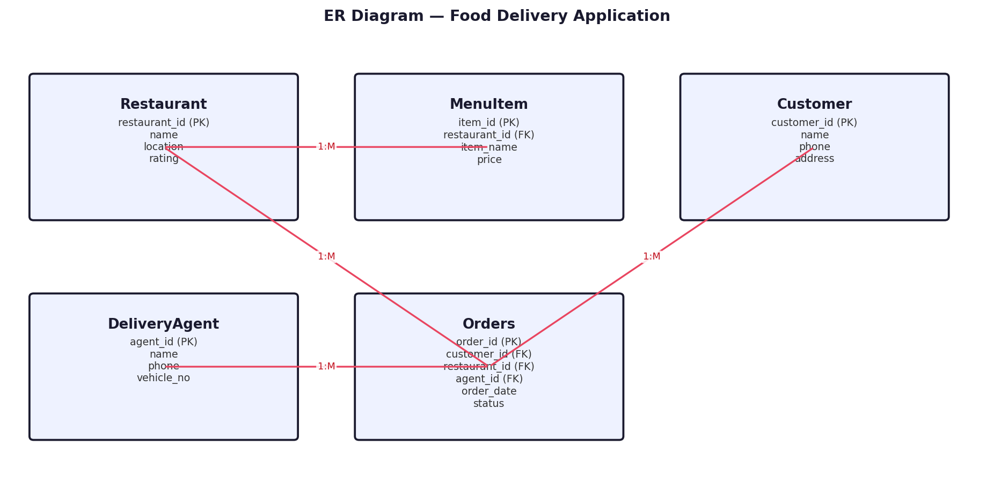
5. Table Design (Columns, Data Types, Keys)
Table | Column | Type | Constraint
Restaurant | restaurant_id | INTEGER | PRIMARY KEY
 | name | TEXT | -
 | location | TEXT | -
 | rating | REAL | -
MenuItem | item_id | INTEGER | PRIMARY KEY
 | restaurant_id | INTEGER | FK -> Restaurant
 | item_name | TEXT | -
 | price | REAL | -
Customer | customer_id | INTEGER | PRIMARY KEY
 | name | TEXT | -
 | phone | TEXT | -
 | address | TEXT | -
DeliveryAgent | agent_id | INTEGER | PRIMARY KEY
 | name | TEXT | -
 | phone | TEXT | -
 | vehicle_no | TEXT | -
Orders | order_id | INTEGER | PRIMARY KEY
 | customer_id | INTEGER | FK -> Customer
 | restaurant_id | INTEGER | FK -> Restaurant
 | agent_id | INTEGER | FK -> DeliveryAgent
 | order_date | TEXT | -
 | status | TEXT | -
6. Normalization
1NF: All attributes hold atomic values, no repeating groups. 2NF: Every non-key attribute depends on the whole primary key; M:N links use a junction table. 3NF: No transitive dependency — e.g. restaurant location depends only on restaurant_id, not on order_id.
7. Database Schema Diagram
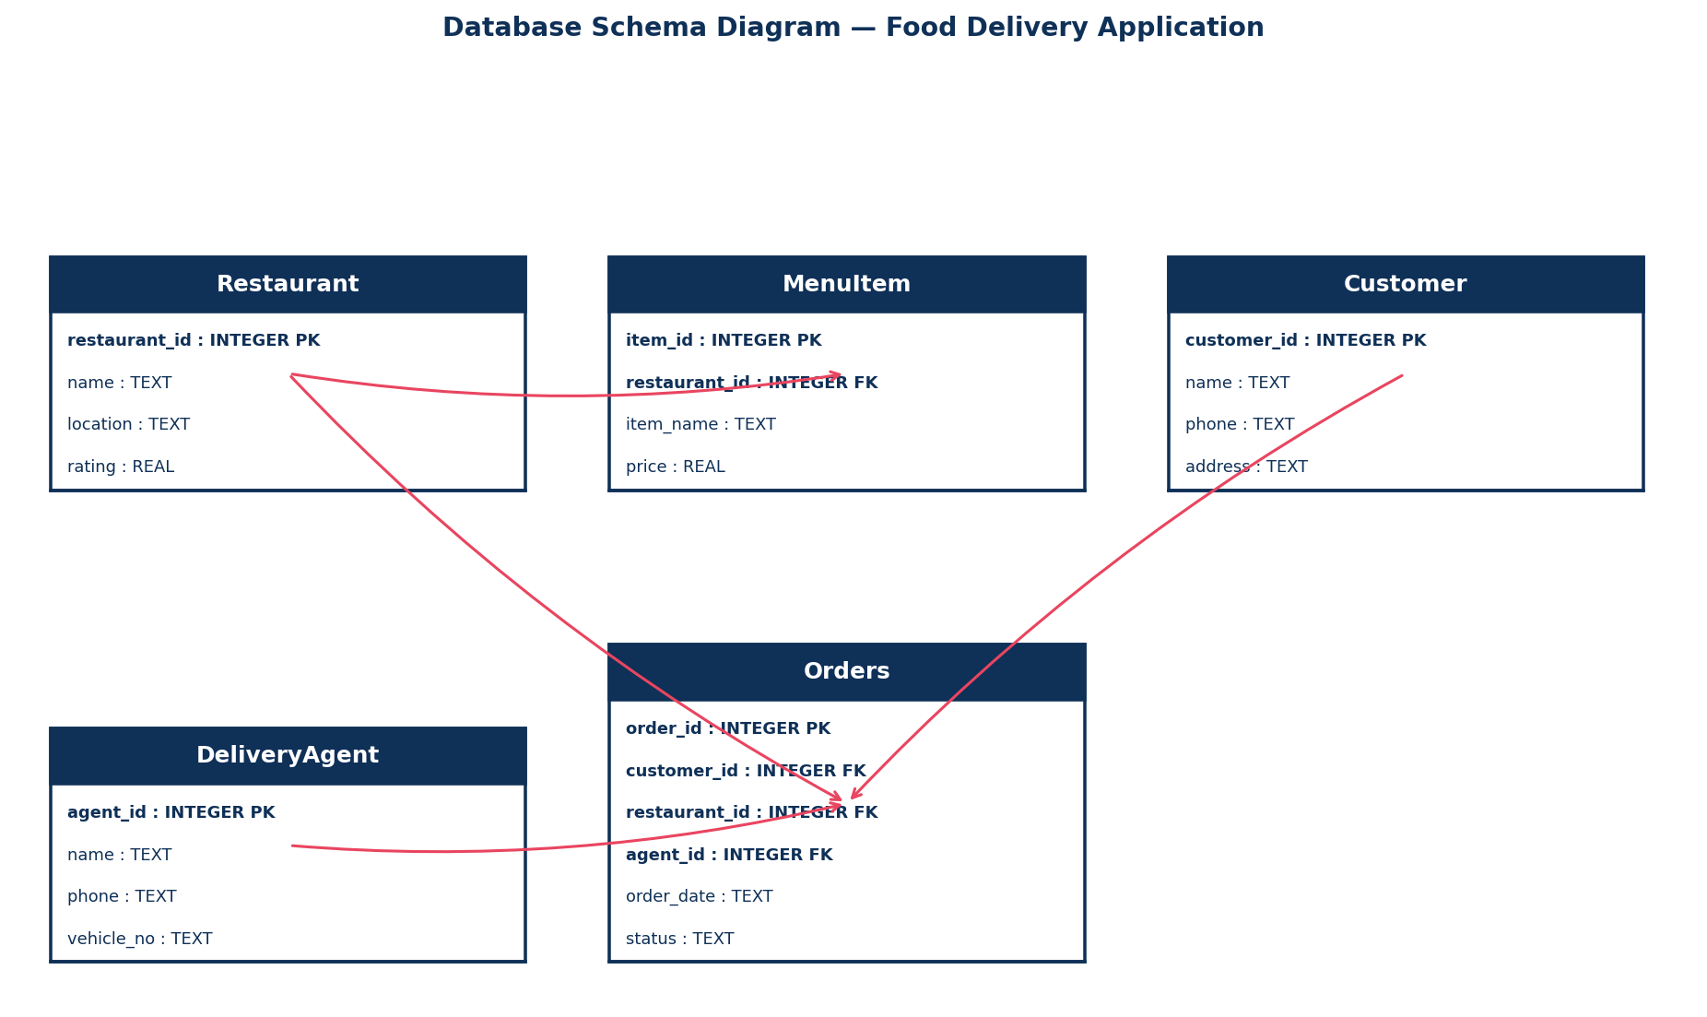
8. SQL CREATE TABLE Statements
CREATE TABLE IF NOT EXISTS Restaurant (
restaurant_id INTEGER PRIMARY KEY AUTOINCREMENT,
name TEXT,
location TEXT,
rating REAL
);
CREATE TABLE IF NOT EXISTS MenuItem (
item_id INTEGER PRIMARY KEY AUTOINCREMENT,
restaurant_id INTEGER,
item_name TEXT,
price REAL,
FOREIGN KEY (restaurant_id) REFERENCES Restaurant(restaurant_id)
);
CREATE TABLE IF NOT EXISTS Customer (
customer_id INTEGER PRIMARY KEY AUTOINCREMENT,
name TEXT,
phone TEXT,
address TEXT
);
CREATE TABLE IF NOT EXISTS DeliveryAgent (
agent_id INTEGER PRIMARY KEY AUTOINCREMENT,
name TEXT,
phone TEXT,
vehicle_no TEXT
);
CREATE TABLE IF NOT EXISTS Orders (
order_id INTEGER PRIMARY KEY AUTOINCREMENT,
customer_id INTEGER,
restaurant_id INTEGER,
agent_id INTEGER,
order_date TEXT,
status TEXT,
FOREIGN KEY (customer_id) REFERENCES Customer(customer_id),
FOREIGN KEY (restaurant_id) REFERENCES Restaurant(restaurant_id),
FOREIGN KEY (agent_id) REFERENCES DeliveryAgent(agent_id)
);
9. Sample Records
Table: Orders
order_id | customer_id | restaurant_id | agent_id | order_date | status
1 | 1 | 1 | 1 | 2026-07-01 | Delivered
2 | 2 | 2 | 2 | 2026-07-01 | Delivered
3 | 3 | 1 | 1 | 2026-07-02 | Preparing
4 | 4 | 3 | 3 | 2026-07-02 | Out for Delivery
5 | 5 | 2 | 2 | 2026-07-03 | Delivered
10. Python SQLite Connectivity Program (CRUD Operations)
# Food Delivery Application | DB: fooddelivery.db | Table: Orders
# (Table already created using the CREATE TABLE statement in Section 8)
import sqlite3
conn = sqlite3.connect("fooddelivery.db")
cur = conn.cursor()

def create_record(values): # CREATE
cur.execute("INSERT INTO Orders (order_id, customer_id, restaurant_id, agent_id, order_date, status) VALUES (?, ?, ?, ?, ?, ?)", values)
conn.commit()

def read_records(): # READ
cur.execute("SELECT * FROM Orders")
for row in cur.fetchall(): print(row)

def update_record(record_id, new_value): # UPDATE
cur.execute("UPDATE Orders SET customer_id = ? WHERE order_id = ?", (new_value, record_id))
conn.commit()

def delete_record(record_id): # DELETE
cur.execute("DELETE FROM Orders WHERE order_id = ?", (record_id,))
conn.commit()

if __name__ == "__main__":
create_record([1,1,1,1,"2026-07-01","Delivered"])
print("-- All Records --"); read_records()
update_record(1, 0)
print("-- After Update --"); read_records()
delete_record(1)
print("-- After Delete --"); read_records()
conn.close()

11. Expected Output
-- All Records --
(1, 1, 1, 1, '2026-07-01', 'Delivered')
(2, 2, 2, 2, '2026-07-01', 'Delivered')
(3, 3, 1, 1, '2026-07-02', 'Preparing')
(4, 4, 3, 3, '2026-07-02', 'Out for Delivery')
(5, 5, 2, 2, '2026-07-03', 'Delivered')
-- After Update: record order_id=1 shows the new value.
-- After Delete: record order_id=1 no longer appears.
12. Result
The relational database for "Food Delivery Application" was designed, normalized up to 3NF, and successfully connected using Python's sqlite3 module. All CRUD operations (Create, Read, Update, Delete) were executed and verified successfully.

Scenario 8: Employee Payroll Management System
1. Aim
To design a relational database for payroll management and implement Python-SQLite connectivity with CRUD operations.
2. Problem Statement
Manual payroll processing using spreadsheets causes salary calculation errors. A database-driven system is needed to manage employees, attendance, salary structures and monthly payroll.
3. Objective
Design entities for Department, Employee, Attendance and Payroll; normalize the schema; implement SQLite connectivity with CRUD operations.
4. ER Diagram
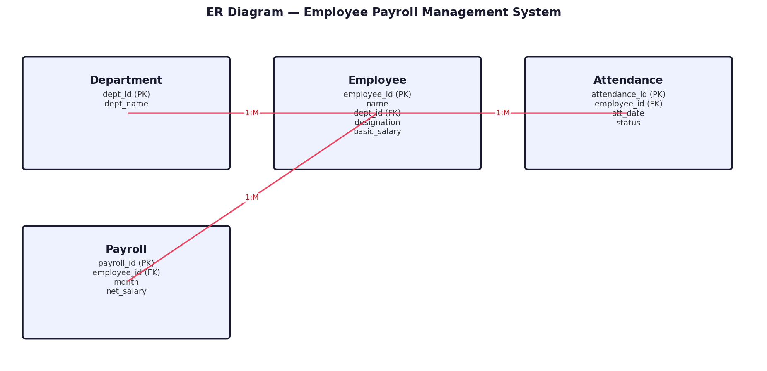
5. Table Design (Columns, Data Types, Keys)
Table | Column | Type | Constraint
Department | dept_id | INTEGER | PRIMARY KEY
 | dept_name | TEXT | -
Employee | employee_id | INTEGER | PRIMARY KEY
 | name | TEXT | -
 | dept_id | INTEGER | FK -> Department
 | designation | TEXT | -
 | basic_salary | REAL | -
Attendance | attendance_id | INTEGER | PRIMARY KEY
 | employee_id | INTEGER | FK -> Employee
 | att_date | TEXT | -
 | status | TEXT | -
Payroll | payroll_id | INTEGER | PRIMARY KEY
 | employee_id | INTEGER | FK -> Employee
 | month | TEXT | -
 | net_salary | REAL | -
6. Normalization
1NF: All attributes hold atomic values, no repeating groups. 2NF: Every non-key attribute depends on the whole primary key; M:N links use a junction table. 3NF: No transitive dependency — e.g. dept_name depends only on dept_id, not on employee_id.
7. Database Schema Diagram
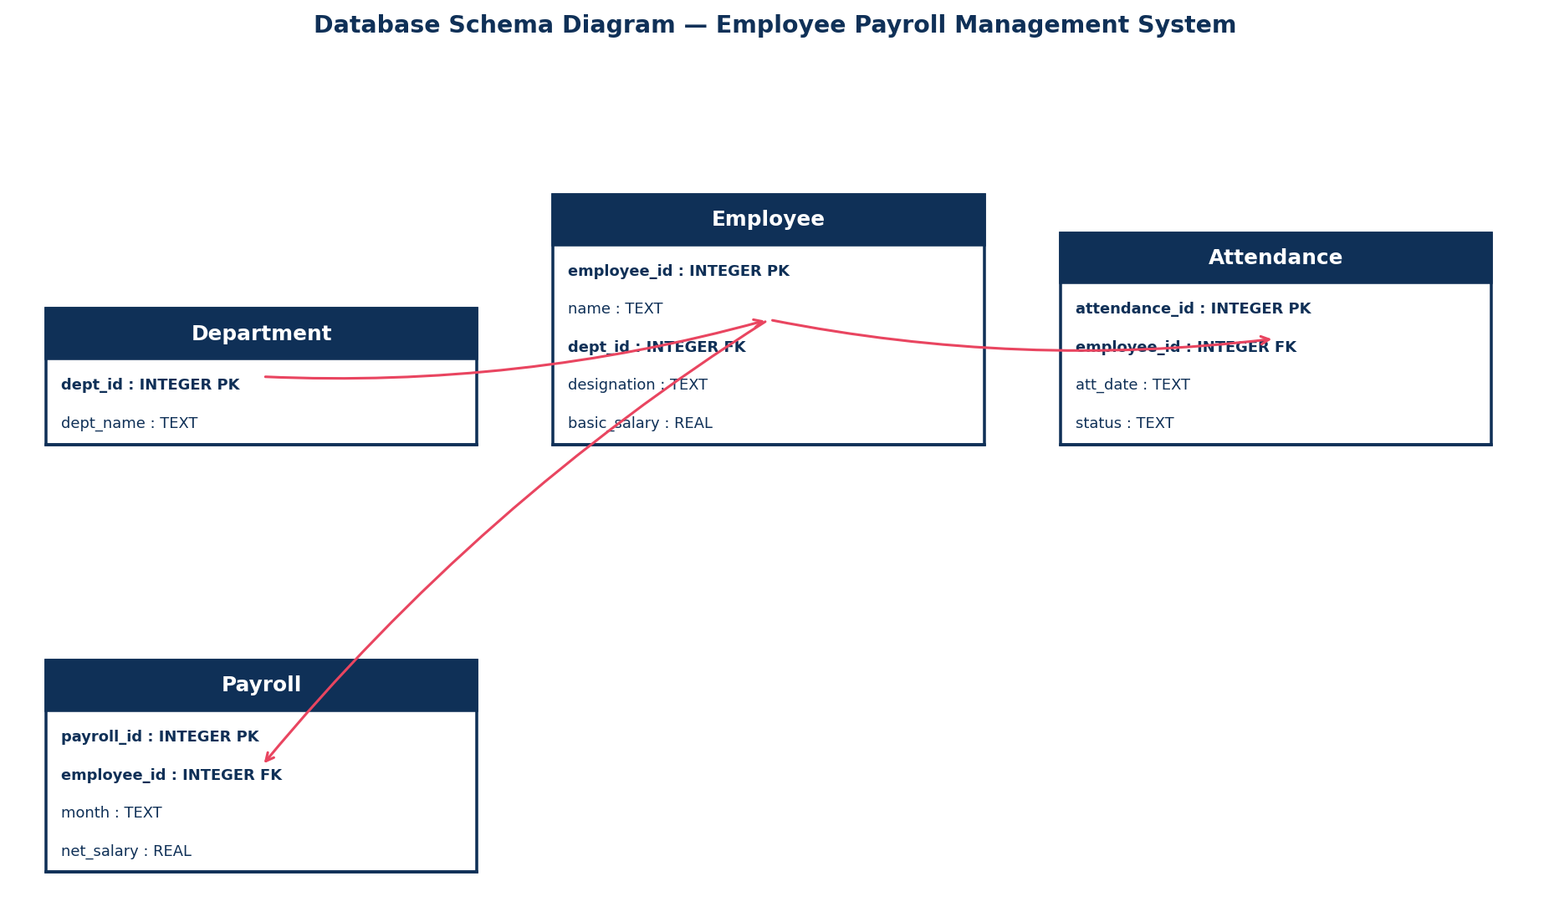
8. SQL CREATE TABLE Statements
CREATE TABLE IF NOT EXISTS Department (
dept_id INTEGER PRIMARY KEY AUTOINCREMENT,
dept_name TEXT
);
CREATE TABLE IF NOT EXISTS Employee (
employee_id INTEGER PRIMARY KEY AUTOINCREMENT,
name TEXT,
dept_id INTEGER,
designation TEXT,
basic_salary REAL,
FOREIGN KEY (dept_id) REFERENCES Department(dept_id)
);
CREATE TABLE IF NOT EXISTS Attendance (
attendance_id INTEGER PRIMARY KEY AUTOINCREMENT,
employee_id INTEGER,
att_date TEXT,
status TEXT,
FOREIGN KEY (employee_id) REFERENCES Employee(employee_id)
);
CREATE TABLE IF NOT EXISTS Payroll (
payroll_id INTEGER PRIMARY KEY AUTOINCREMENT,
employee_id INTEGER,
month TEXT,
net_salary REAL,
FOREIGN KEY (employee_id) REFERENCES Employee(employee_id)
);
9. Sample Records
Table: Employee
employee_id | name | dept_id | designation | basic_salary
1 | Vignesh Kumar | 1 | Technician | 28000
2 | Anitha Raj | 2 | Supervisor | 42000
3 | Manoj Kannan | 1 | Technician | 27000
4 | Deepa Ramesh | 3 | HR Executive | 35000
5 | Sanjay Babu | 2 | Supervisor | 41000
10. Python SQLite Connectivity Program (CRUD Operations)
# Employee Payroll Management System | DB: payroll.db | Table: Employee
# (Table already created using the CREATE TABLE statement in Section 8)
import sqlite3
conn = sqlite3.connect("payroll.db")
cur = conn.cursor()

def create_record(values): # CREATE
cur.execute("INSERT INTO Employee (employee_id, name, dept_id, designation, basic_salary) VALUES (?, ?, ?, ?, ?)", values)
conn.commit()

def read_records(): # READ
cur.execute("SELECT * FROM Employee")
for row in cur.fetchall(): print(row)

def update_record(record_id, new_value): # UPDATE
cur.execute("UPDATE Employee SET name = ? WHERE employee_id = ?", (new_value, record_id))
conn.commit()

def delete_record(record_id): # DELETE
cur.execute("DELETE FROM Employee WHERE employee_id = ?", (record_id,))
conn.commit()

if __name__ == "__main__":
create_record([1,"Vignesh Kumar",1,"Technician",28000])
print("-- All Records --"); read_records()
update_record(1, "Updated Name")
print("-- After Update --"); read_records()
delete_record(1)
print("-- After Delete --"); read_records()
conn.close()

11. Expected Output
-- All Records --
(1, 'Vignesh Kumar', 1, 'Technician', 28000)
(2, 'Anitha Raj', 2, 'Supervisor', 42000)
(3, 'Manoj Kannan', 1, 'Technician', 27000)
(4, 'Deepa Ramesh', 3, 'HR Executive', 35000)
(5, 'Sanjay Babu', 2, 'Supervisor', 41000)
-- After Update: record employee_id=1 shows the new value.
-- After Delete: record employee_id=1 no longer appears.
12. Result
The relational database for "Employee Payroll Management System" was designed, normalized up to 3NF, and successfully connected using Python's sqlite3 module. All CRUD operations (Create, Read, Update, Delete) were executed and verified successfully.

Scenario 9: Online Learning Management System
1. Aim
To design a relational database for an online learning platform and implement Python-SQLite connectivity with CRUD operations.
2. Problem Statement
The platform needs to maintain student profiles, instructor details, courses, enrollments, assignments and grades to track student progress and course completion.
3. Objective
Design entities for Instructor, Course, Student, Enrollment and Assignment; normalize the schema; implement SQLite connectivity with CRUD operations.
4. ER Diagram
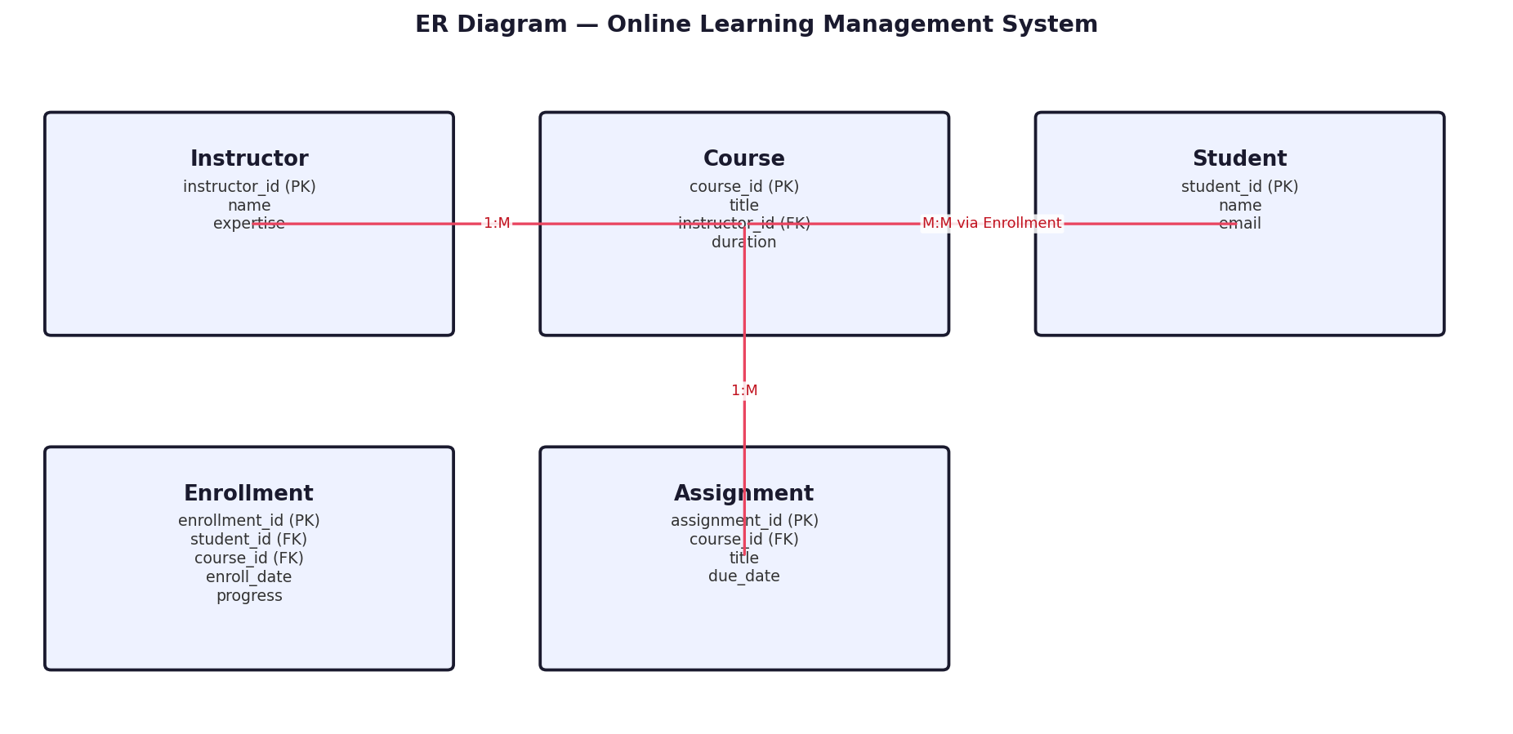
5. Table Design (Columns, Data Types, Keys)
Table | Column | Type | Constraint
Instructor | instructor_id | INTEGER | PRIMARY KEY
 | name | TEXT | -
 | expertise | TEXT | -
Course | course_id | INTEGER | PRIMARY KEY
 | title | TEXT | -
 | instructor_id | INTEGER | FK -> Instructor
 | duration | TEXT | -
Student | student_id | INTEGER | PRIMARY KEY
 | name | TEXT | -
 | email | TEXT | -
Enrollment | enrollment_id | INTEGER | PRIMARY KEY
 | student_id | INTEGER | FK -> Student
 | course_id | INTEGER | FK -> Course
 | enroll_date | TEXT | -
 | progress | TEXT | -
Assignment | assignment_id | INTEGER | PRIMARY KEY
 | course_id | INTEGER | FK -> Course
 | title | TEXT | -
 | due_date | TEXT | -
6. Normalization
1NF: All attributes hold atomic values, no repeating groups. 2NF: Every non-key attribute depends on the whole primary key; M:N links use a junction table. 3NF: No transitive dependency — e.g. expertise depends only on instructor_id, not on course_id.
7. Database Schema Diagram
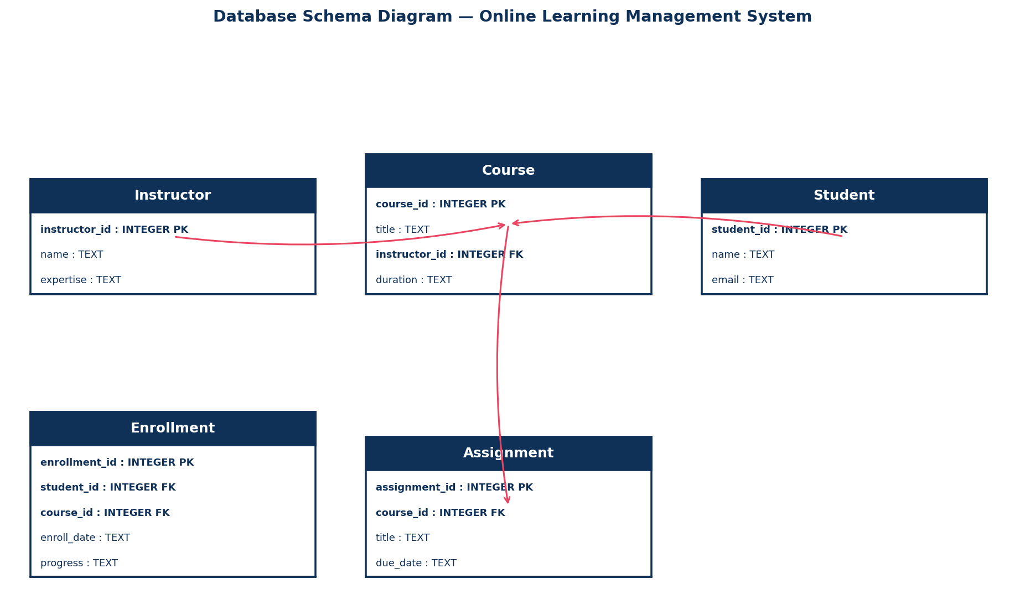
8. SQL CREATE TABLE Statements
CREATE TABLE IF NOT EXISTS Instructor (
instructor_id INTEGER PRIMARY KEY AUTOINCREMENT,
name TEXT,
expertise TEXT
);
CREATE TABLE IF NOT EXISTS Course (
course_id INTEGER PRIMARY KEY AUTOINCREMENT,
title TEXT,
instructor_id INTEGER,
duration TEXT,
FOREIGN KEY (instructor_id) REFERENCES Instructor(instructor_id)
);
CREATE TABLE IF NOT EXISTS Student (
student_id INTEGER PRIMARY KEY AUTOINCREMENT,
name TEXT,
email TEXT
);
CREATE TABLE IF NOT EXISTS Enrollment (
enrollment_id INTEGER PRIMARY KEY AUTOINCREMENT,
student_id INTEGER,
course_id INTEGER,
enroll_date TEXT,
progress TEXT,
FOREIGN KEY (student_id) REFERENCES Student(student_id),
FOREIGN KEY (course_id) REFERENCES Course(course_id)
);
CREATE TABLE IF NOT EXISTS Assignment (
assignment_id INTEGER PRIMARY KEY AUTOINCREMENT,
course_id INTEGER,
title TEXT,
due_date TEXT,
FOREIGN KEY (course_id) REFERENCES Course(course_id)
);
9. Sample Records
Table: Student
student_id | name | email
1 | Aditi Menon | aditi@lms.com
2 | Rahul Nair | rahul@lms.com
3 | Pooja Iyer | pooja@lms.com
4 | Vivek Shankar | vivek@lms.com
5 | Nisha Pillai | nisha@lms.com
10. Python SQLite Connectivity Program (CRUD Operations)
# Online Learning Management System | DB: lms.db | Table: Student
# (Table already created using the CREATE TABLE statement in Section 8)
import sqlite3
conn = sqlite3.connect("lms.db")
cur = conn.cursor()

def create_record(values): # CREATE
cur.execute("INSERT INTO Student (student_id, name, email) VALUES (?, ?, ?)", values)
conn.commit()

def read_records(): # READ
cur.execute("SELECT * FROM Student")
for row in cur.fetchall(): print(row)

def update_record(record_id, new_value): # UPDATE
cur.execute("UPDATE Student SET name = ? WHERE student_id = ?", (new_value, record_id))
conn.commit()

def delete_record(record_id): # DELETE
cur.execute("DELETE FROM Student WHERE student_id = ?", (record_id,))
conn.commit()

if __name__ == "__main__":
create_record([1,"Aditi Menon","aditi@lms.com"])
print("-- All Records --"); read_records()
update_record(1, "Updated Name")
print("-- After Update --"); read_records()
delete_record(1)
print("-- After Delete --"); read_records()
conn.close()

11. Expected Output
-- All Records --
(1, 'Aditi Menon', 'aditi@lms.com')
(2, 'Rahul Nair', 'rahul@lms.com')
(3, 'Pooja Iyer', 'pooja@lms.com')
(4, 'Vivek Shankar', 'vivek@lms.com')
(5, 'Nisha Pillai', 'nisha@lms.com')
-- After Update: record student_id=1 shows the new value.
-- After Delete: record student_id=1 no longer appears.
12. Result
The relational database for "Online Learning Management System" was designed, normalized up to 3NF, and successfully connected using Python's sqlite3 module. All CRUD operations (Create, Read, Update, Delete) were executed and verified successfully.

Scenario 10: Smart Transportation and Ticket Booking System
1. Aim
To design a relational database for a bus transportation system and implement Python-SQLite connectivity with CRUD operations.
2. Problem Statement
The transportation company needs to maintain buses, routes, drivers, passengers and bookings to analyze demand and support online ticket booking and cancellation.
3. Objective
Design entities for Bus, Route, Passenger and Booking; normalize the schema; implement SQLite connectivity with CRUD operations.
4. ER Diagram
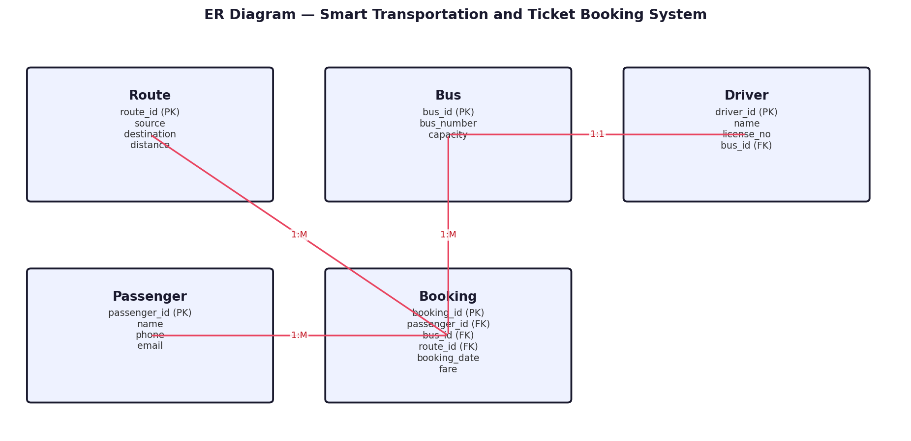
5. Table Design (Columns, Data Types, Keys)
Table | Column | Type | Constraint
Route | route_id | INTEGER | PRIMARY KEY
 | source | TEXT | -
 | destination | TEXT | -
 | distance | REAL | -
Bus | bus_id | INTEGER | PRIMARY KEY
 | bus_number | TEXT | -
 | capacity | INTEGER | -
Driver | driver_id | INTEGER | PRIMARY KEY
 | name | TEXT | -
 | license_no | TEXT | -
 | bus_id | INTEGER | FK -> Bus
Passenger | passenger_id | INTEGER | PRIMARY KEY
 | name | TEXT | -
 | phone | TEXT | -
 | email | TEXT | -
Booking | booking_id | INTEGER | PRIMARY KEY
 | passenger_id | INTEGER | FK -> Passenger
 | bus_id | INTEGER | FK -> Bus
 | route_id | INTEGER | FK -> Route
 | booking_date | TEXT | -
 | fare | REAL | -
6. Normalization
1NF: All attributes hold atomic values, no repeating groups. 2NF: Every non-key attribute depends on the whole primary key; M:N links use a junction table. 3NF: No transitive dependency — e.g. source/destination depend only on route_id, not on booking_id.
7. Database Schema Diagram
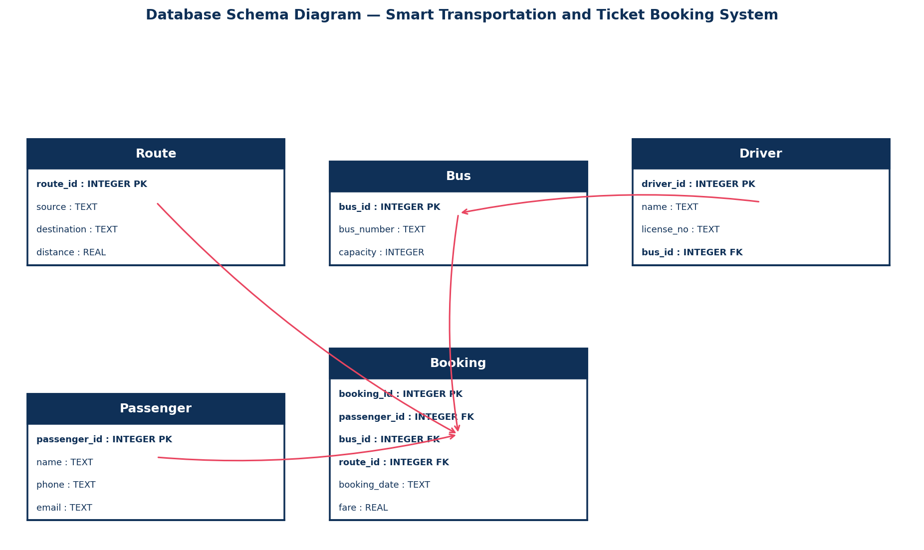
8. SQL CREATE TABLE Statements
CREATE TABLE IF NOT EXISTS Route (
route_id INTEGER PRIMARY KEY AUTOINCREMENT,
source TEXT,
destination TEXT,
distance REAL
);
CREATE TABLE IF NOT EXISTS Bus (
bus_id INTEGER PRIMARY KEY AUTOINCREMENT,
bus_number TEXT,
capacity INTEGER
);
CREATE TABLE IF NOT EXISTS Driver (
driver_id INTEGER PRIMARY KEY AUTOINCREMENT,
name TEXT,
license_no TEXT,
bus_id INTEGER,
FOREIGN KEY (bus_id) REFERENCES Bus(bus_id)
);
CREATE TABLE IF NOT EXISTS Passenger (
passenger_id INTEGER PRIMARY KEY AUTOINCREMENT,
name TEXT,
phone TEXT,
email TEXT
);
CREATE TABLE IF NOT EXISTS Booking (
booking_id INTEGER PRIMARY KEY AUTOINCREMENT,
passenger_id INTEGER,
bus_id INTEGER,
route_id INTEGER,
booking_date TEXT,
fare REAL,
FOREIGN KEY (passenger_id) REFERENCES Passenger(passenger_id),
FOREIGN KEY (bus_id) REFERENCES Bus(bus_id),
FOREIGN KEY (route_id) REFERENCES Route(route_id)
);
9. Sample Records
Table: Passenger
passenger_id | name | phone | email
1 | Harish Kumar | 9123456780 | harish@mail.com
2 | Swathi Menon | 9123456781 | swathi@mail.com
3 | Bala Murugan | 9123456782 | bala@mail.com
4 | Ramya Krishnan | 9123456783 | ramya@mail.com
5 | Naveen Raj | 9123456784 | naveen@mail.com
10. Python SQLite Connectivity Program (CRUD Operations)
# Smart Transportation and Ticket Booking System | DB: transport.db | Table: Passenger
# (Table already created using the CREATE TABLE statement in Section 8)
import sqlite3
conn = sqlite3.connect("transport.db")
cur = conn.cursor()

def create_record(values): # CREATE
cur.execute("INSERT INTO Passenger (passenger_id, name, phone, email) VALUES (?, ?, ?, ?)", values)
conn.commit()

def read_records(): # READ
cur.execute("SELECT * FROM Passenger")
for row in cur.fetchall(): print(row)

def update_record(record_id, new_value): # UPDATE
cur.execute("UPDATE Passenger SET name = ? WHERE passenger_id = ?", (new_value, record_id))
conn.commit()

def delete_record(record_id): # DELETE
cur.execute("DELETE FROM Passenger WHERE passenger_id = ?", (record_id,))
conn.commit()

if __name__ == "__main__":
create_record([1,"Harish Kumar","9123456780","harish@mail.com"])
print("-- All Records --"); read_records()
update_record(1, "Updated Name")
print("-- After Update --"); read_records()
delete_record(1)
print("-- After Delete --"); read_records()
conn.close()

11. Expected Output
-- All Records --
(1, 'Harish Kumar', '9123456780', 'harish@mail.com')
(2, 'Swathi Menon', '9123456781', 'swathi@mail.com')
(3, 'Bala Murugan', '9123456782', 'bala@mail.com')
(4, 'Ramya Krishnan', '9123456783', 'ramya@mail.com')
(5, 'Naveen Raj', '9123456784', 'naveen@mail.com')
-- After Update: record passenger_id=1 shows the new value.
-- After Delete: record passenger_id=1 no longer appears.
12. Result
The relational database for "Smart Transportation and Ticket Booking System" was designed, normalized up to 3NF, and successfully connected using Python's sqlite3 module. All CRUD operations (Create, Read, Update, Delete) were executed and verified successfully.

